Model Website Text
CHRISTIAN FAITH AND EARTH DAY SUNDAY
The Bible is full of beautiful language and theology for celebrating God's Creation. Yet sometimes, in the rhythm of the liturgical year, it can be challenging to find a specific time to focus as a church community on the theme of Creation. Earth Day Sunday provides just such an opportunity. Since 1970, communities have taken one day each year to be especially mindful of the Earth and its many gifts: April 22, Earth Day. Soon after, churches started celebrating God’s creation on the Sunday closest to Earth Day. This day has ecumenical and bipartisan roots.

GET INVOLVED
Do you want to plan an Earth Day celebration in your congregation? Consider using our theme materials for this year, which focus on embracing a “sense of place.” To connect with others who are planning Earth Day Sunday activities, join the Earth Day Sunday 2018 Facebook event. You can also find a treasure trove of Earth Day Sunday resources from previous years covering various themes on Creation Justice Ministries’ education resource page.

ABOUT CREATION JUSTICE MINISTRIES
Our faith community is an active member of Creation Justice Ministries. Creation Justice Ministries is an ecumenical organization that continues the work of the former Eco-Justice Program of the National Council of Churches.

Each year, Creation Justice Ministries focuses on a particular ecological theme chosen by our members. We highlight a number of ways individuals and congregations can celebrate and protect God's creation. We hope these ideas inspire further thoughts, conversations, and actions in answering God's call to be faithful stewards of Creation.

Model Email

Dear [[Name]],
April 22 is Earth Day, and in 2018, it falls on a Sunday! Is your faith community ready to celebrate God’s good creation? Find a resource from Creation Justice Ministries to equip you with preaching, teaching, prayer, and action materials at www.earthdaysunday.org. To connect with others who are planning Earth Day Sunday activities, join the Earth Day Sunday 2018 Facebook event. Our faith community is active with Creation Justice Ministries and we hope you will find these materials useful!
Each year before Earth Day, Creation Justice Ministries offers Christian education materials to equip faith communities to protect, restore, and more rightly share God's creation. The 2018 theme is "Sense of Place" and offers insights about living in harmony with local ecosystems and watersheds, rightly sharing places with a diversity of peoples, and respecting the history of your place.
In Hope,
[[Name]]
[[Title]], [[Communion/Org]]

Model Social Media Content
Tweets:
- Celebrate #EarthDay2018 on April 22. Find resources from @CreationJustice at www.earthdaysunday.org [attach image]
- This #EarthDay, let’s feel a Sense of Place and reconnect with our watersheds. Find resources via @CreationJustice to do it at www.earthdaysunday.org [attach image]
- Join a community of people exchanging ideas about celebrating #EarthDaySunday / #EarthDay on Facebook: https://www.facebook.com/events/887749344718652/
- RETWEET: https://twitter.com/CreationJustice/status/974533592603795456
Facebook/Instagram
- The Bible is full of beautiful language and theology for celebrating God's creation. Yet sometimes, in the rhythm of the liturgical year, it can be challenging to find a specific time to focus as a church community on the theme of Creation. Earth Day Sunday provides just such an opportunity. Get ready for Sunday, April 22! Find resources from @Creation Justice Ministries at www.earthdaysunday.org [attach image]
- Share on Facebook: https://www.facebook.com/CreationJustice/photos/a.226829344019085.48098.200065186695501/1649364985098840/?type=3&theater
Instagram
- Celebrate #EarthDaySunday on April 22 with @CreationJustice. Find resources at www.earthdaysunday.org #EarthDayEveryDay #CreationCare #CreationJustice
- Share on Instagram: https://www.instagram.com/p/BgYLOgknulj/?taken-by=creationjustice

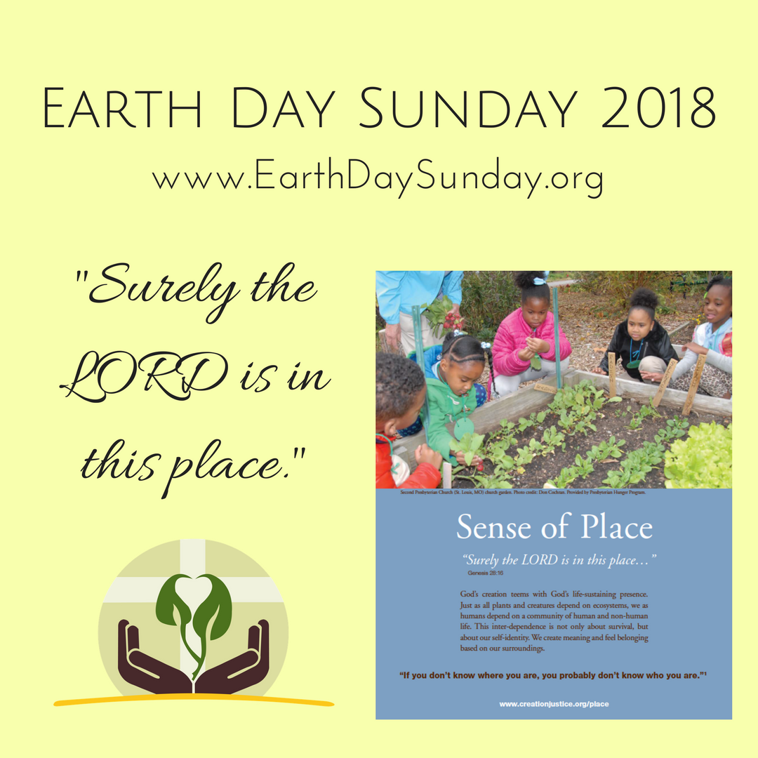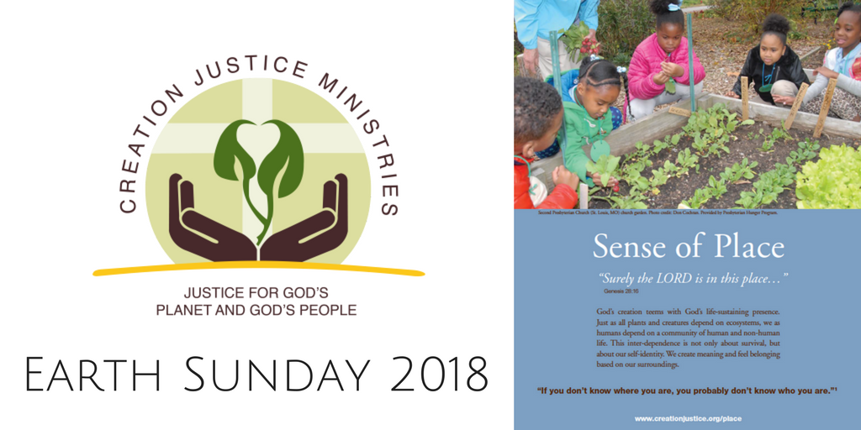

Denominational Press Release
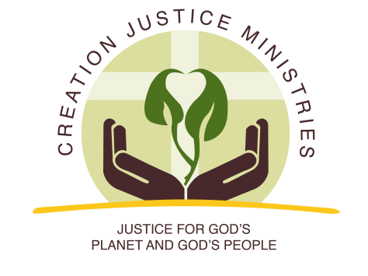
NEWS RELEASE
For Immediate Release:
March 16, 2018
Contact: Shantha Ready Alonso, (202) 618-2501 (mobile) shantha@creationjustice.org

Ecumenical Leaders Call on Churches to Reflect on “Sense of Place” for Earth Day Sunday
Annual Earth Day Sunday Celebration Observed by Thousands of Churches Nationwide

On April 22, 2018, many churches across the United States will observe Earth Day Sunday. Since 1970, communities have taken one day each year to be especially mindful of the Earth and its many gifts: April 22, Earth Day. This is a liturgical year that Earth Day and Sunday fall on the same day, and that Earth Day neither conflicts with Holy Week nor Easter Sunday.

Each year, Creation Justice Ministries, an ecumenical continuation of the National Council of Churches’ Eco-Justice Program, provides Earth Day Sunday celebration resources. The theme each year is chosen by ecumenical leaders from Creation Justice Ministries’ member communions based on what issue they believe is most pressing. In the resource, the urgency of embracing “sense of place” is expressed this way:
“On any given day in the United States, it is possible to drink coffee from Guatemala, while wearing clothes made in Bangladesh, while sheltered under a roof that was partly manufactured in China. The average U.S. adult devotes approximately ten hours a day to consuming media^{[1]}, spends 87 percent of their time indoors and passes another six percent of their time inside a vehicle.^{[2]} Today, connecting with our local communities requires intention.”

The “Sense of Place” Earth Day Sunday resource includes materials to reflect, teach, preach, pray, and act to preserve a “sense of place” in our communities. The education section of the resource begins with a poignant quote from Ralph Ellison’s The Invisible Man: “If you don’t know where you are, you probably don’t know who you are.”^{[3]}

Ecumenical leaders’ intention for the resource is to encourage Christians in the United States to engage in spiritual practices that help us be more present to one another and our local watersheds. The resource encourages bioregional faith practices such as familiarizing ourselves with our watersheds and using them as a frame of reference for gatherings, as well as speaking aloud Indigenous territory acknowledgements at the beginning of gatherings. The Bible Study in the resource includes an invitation to read Psalm 104 in context by imagining how it would sound when referencing plants, creatures, and geological features familiar to our own watersheds.

The resource also explores connections between place and racism. It reads: “While places encompass all, and should include all peoples as co-inhabitants, places have often been seen as possessions, and inhabitants as objects of conquest. Our relationship with our watershed and its inhabitants is affected by, and has shaped, our understanding of race and ethnicity.” The piece touches on themes such as the Doctrine of Discovery, redlining, gentrification, and sacrifice zones.

In the action section, the resource invites congregants to get to know their local public lands and waters, participate in garden ministries, care for water, and protect nearby threatened and endangered species. The resource also includes tools to assist faith communities considering honoring Endangered Species Day on Friday, May 18.

Find all this and more at www.earthdaysunday.org.

###

Creation Justice Ministries brings together 38 Christian communions, including Baptists, mainline Protestants, Historically Black Churches, Peace Churches, and Orthodox communions. Learn more at www.creationjustice.org

[1] Nielsen Total Audience Report, http://www.nielsen.com/us/en/insights/reports/2016/the-total-audience-report-q1-2016.html.
[2] National Human Activity Pattern Survey, (NHAPS) https://www.ncbi.nlm.nih.gov/pubmed/11477521.
^{[3]} Ralph Ellison, Invisible Man, New York: Vintage Books, 1982, p. 564.

