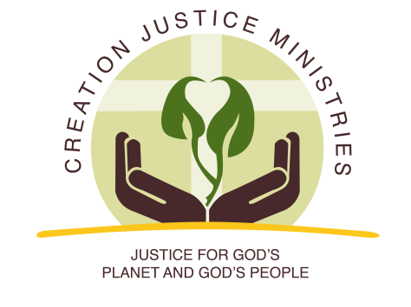
NEWS RELEASE

For Immediate Release:
October 6, 2016
Contact: Shantha Ready Alonso, 760.408.0688 (mobile) shantha@creationjustice.org

Top Southwestern and National Faith Leaders Call for Protection of the Greater Grand Canyon Heritage Area
Leaders cite water justice, racial justice, and conservation as reasons to designate area as a national monument

Today, 32 top religious leaders of Jewish and Christian traditions, including bishops, regional ministers, and executive directors, have sent a letter to President Obama calling on him to permanently protect the Greater Grand Canyon Heritage Area by designating it as a national monument.

Signers ranged the head of the Presbyterian Church (USA) Rev. Dr. J. Herbert Nelson, to widely read and beloved Christian theologians such as Fr. Richard Rohr and Dr. Larry Rasmussen. The letter had an urgency to it, asking him to act “before it is too late,” as the Greater Grand Canyon Heritage Area’s temporary protection from uranium mining could end soon.

Water protection was the first and most emphasized theme in the letter: “We have already seen the devastation of uranium mining on local communities’ drinking water supplies, with cancer clusters developing among communities with few resources to cope. Many impacted communities waited far too long for justice, and some are still waiting. Today, there are too few mechanisms in place to ensure such tragedies will not reoccur.”

The letter recognized that Native American communities in the area were not only most vulnerable to water pollution impacts, but also to destruction of cultural and spiritual practices connected to the land. The letter went on to say, “We stand with our indigenous neighbors to defend health, dignity, and justice for all.”

Lastly, the letter emphasized the importance of species protection and conservation, noting “We must steward the gifts of the natural world wisely so that future generations of all God’s creatures, including humans, can also enjoy its abundance.”

Creation Justice Ministries Executive Director Shantha Ready Alonso said of the letter, “Religious leaders of Judeo-Christian heritage know the first job God gave us in Genesis was to care for the Earth. We know leaving the Greater Grand Canyon Heritage Area unprotected would be reckless, endangering water for future generations.”

###

Creation Justice Ministries represents the creation care policies of 38 Christian communions, including Baptists, mainline Protestants, Historically Black Churches, Peace Churches, and Orthodox communions. Learn more at www.creationjustice.org

