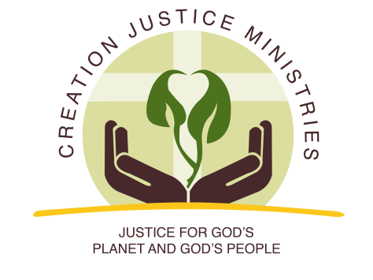
NEWS RELEASE

For Immediate Release:
November 15, 2016
Contact: Shantha Ready Alonso, 760.408.0688 (mobile) shantha@creationjustice.org

Faith Communities Celebrate Arrival of Bureau of Land Management Methane Waste Standard
Cutting Methane Waste on Public Lands Means More Abundance for All

Today, the Bureau of Land Management (BLM) released a finalized Methane Waste Standard, officially called the “Waste Prevention, Production Subject to Royalties, and Resource Conservation Rule.” The Methane Waste Standard will require oil and gas operations on BLM and tribal lands to detect and plug methane leaks, as well as cut the practice of venting and flaring excess methane.

Since the Bureau of Land Management first announced their effort to cut methane waste, religious communities have championed the cause. When methane leaks from oil and gas operations on public land, a useful gift of God’s creation instead becomes a burden to communities. It pollutes the air we breathe, endangers health, and damages the climate. Annually, oil and gas operations in the United States waste enough methane to power the entire state of Wyoming for a year. It is also a revenue loss for companies and taxpayers. If wasted methane could be sold, it would help workers and communities.

Creation Justice Ministries Executive Director Shantha Ready Alonso said, “This is a common sense move that will benefit everyone’s bottom line. We are grateful the Administration followed through and got it done. We call on oil and gas companies to embrace the Methane Waste Standard as an opportunity for better stewardship of methane, which is a finite gift of God’s creation.”

Wyoming Association of Churches Executive Director Chesie Lee said, "We thank the BLM for this rule to discourage waste of a precious resource of God's creation while potentially bringing us more revenue for our schools. At a time when we are facing severe cuts due to a decline of existing revenues available for the State of Wyoming, children can benefit from this improvement in resource stewardship.”

Colorado Council of Churches Executive Director Adrian Miller commented, “As people of faith concerned about being good stewards of the earth, we thank President Obama and his administration for their leadership on improving regulations that will help reduce methane waste.”

Sister Joan Brown, osf, the Executive Director of New Mexico Interfaith Power and Light, commented, "People of faith in New Mexico are grateful for the new BLM methane rules addressing pollution and waste. This is an important step in reducing the large methane cloud in our Four Corners region that will protect the health of those who are most vulnerable. Our schools and the children will benefit from more funds into our state budget from royalties. New Mexico Interfaith Power and Light is grateful for the leadership of this rule that cares for God's creation and our communities."

###

Creation Justice Ministries represents the creation care policies of 38 Christian communions, including Baptists, mainline Protestants, Historically Black Churches, Peace Churches, and Orthodox communions. Learn more at www.creationjustice.org

