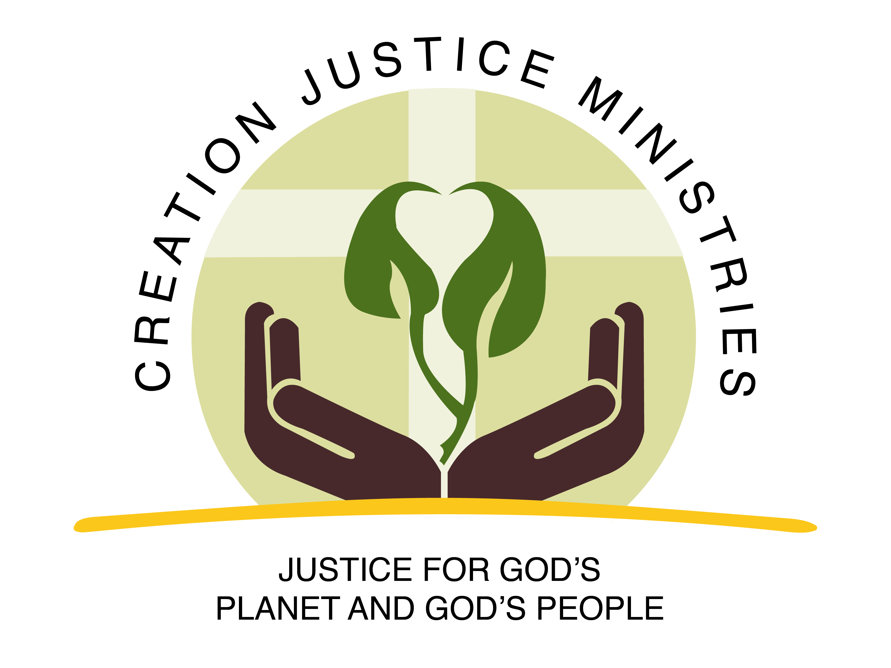
Fact Sheet: Magnuson-Stevens Fishery Conservation and Management Act
public policy designed to balance fishing and upholding the integrity of God’s marine creation
“The oceans are in peril. They cannot protect themselves. But God has endowed humankind with the knowledge to rectify our mistakes, and we are, each one of us, given the choice of what we will do. To protect the oceans is to do God’s work. To harm them, even if we are ignorant of the harm we cause, is to diminish His divine creation. We can stop over-fishing and destructive fishing methods so that the miracle of the fishes will endure for future generations… If we can find the faith to love each other and to love God, then we can find the faith to help His vast water planet to live and flourish.” Patriarch Bartholomew, “The Immortality of Indifference” Homily in Uspenski Orthodox Cathedral, Helsinki (June 6, 2003), Symposium V

Why is commercial fishing a moral matter of stewardship?
God’s creation is abundant enough to sustain everyone’s need. In the book of Genesis, God calls on humanity to steward all of creation. As stewards, we are called to rightly share the fruits of God’s creation with all humanity, with other plants and creatures, and with future generations. This stewardship requires thoughtful planning, conservation, and accountability.

Unfortunately, when we take too many fish at once, fish populations cannot sustain themselves. The United Nations Food and Agriculture Organization’s (FAO) analysis of assessed commercial fish stocks showed that proportion of fish stocks at or above biologically sustainable levels decreased from 90 percent in 1974 to 68.6 percent in 2013. A full 31.4 percent of fish stocks were estimated as fished at a biologically unsustainable level.

What does the Magnuson-Stevens Fishery Conservation and Management Act do?
First passed in 1976, and improved with bipartisan support in 1996 and 2006, the Magnuson-Stevens Act is the primary law governing U.S. ocean fisheries management. Under the Magnuson-Stevens Act, U.S. fisheries management is held to a transparent and public process of science, management, innovation, and collaboration with the fishing industry. It fosters long-term biological and economic sustainability of our nation’s marine fisheries by:
- Preventing overfishing.
- Rebuilding overfished stocks.
- Increasing long-term economic and social benefits.
- Ensuring a safe and sustainable supply of seafood.
What is threatening sustainable fishing practices?
Congress is actively considering legislation to roll back the Magnuson-Stevens Act. The week of June 24, the House of Representatives will vote on one such bill, HR 200. This bill should be called the Empty Oceans Act—it would turn back the clock on conservation of our country’s fisheries, creating loopholes and exemptions from requirements for science-based annual catch limits and preventing overfishing. HR 200 would essentially eliminate the law’s requirement to restore depleted fisheries, or to recover God’s bounty for the prosperity of current and future generations.

How can I help foster responsible stewardship of fisheries, prosperous coastal communities, and healthy oceans?
- Call (202) 224-3121 to contact your U.S. representative and urge a “no” vote on HR 200, or any legislation that weakens the Magnuson-Stevens Act.
- Spread the news that God’s marine creation could be put in danger by returning to the days of overfishing and depleted fisheries.

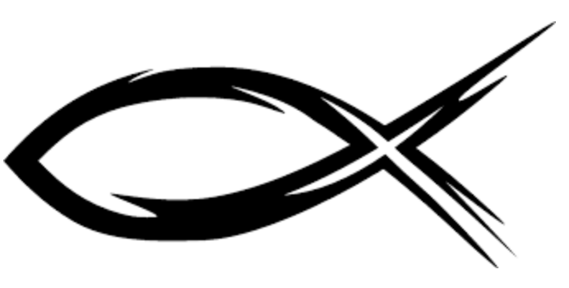
There is the sea, vast and spacious, teeming with creatures beyond number—living things both large and small. Psalm 104:25

The State of World Fisheries and Aquaculture. United Nations Food and Agriculture Organization: Contributing to Food Security and Nutrition for All. Rome 2016. http://www.fao.org/3/a-i5555e.pdf
National Oceanic and Atmospheric Administration. Laws and Policies: Magnuson-Stevens Act. https://www.fisheries.noaa.gov/topic/laws-policies#magnuson-stevens-act

