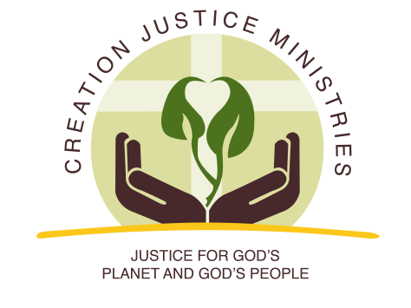
NEWS RELEASE

For Immediate Release:
November 16, 2016
Contact: Shantha Ready Alonso, 760.408.0688 (mobile) shantha@creationjustice.org

Pacific Northwest and National Faith Leaders Call for Cascade-Siskiyou National Monument Expansion
Leaders cite biodiversity and reverence for God’s creation among top reasons for support

Today, 25 Christian leaders sent a letter to President Obama and Secretary Jewell urging them to “care for God’s creation with the reverence it merits, and expand the Cascade-Siskiyou National Monument this year.”

The letter highlights the importance of biodiversity from a religious perspective, and expresses concern that a growing number of scientists report that a “patchwork of vital habitats and watersheds remain unprotected.” The letter goes on to say if these unprotected areas were to be harmed, “we could disrupt the wildlife safe-haven our communities have striven to create over the past 16 years.”

Bishop Staccato Powell of the Western Episcopal District of the African Methodist Episcopal Zion Church said of the proposed monument expansion, “It is no coincidence that President Obama has protected more land and water than any of his predecessors. As a man of deep Christian faith and as a father, he speaks compellingly about our moral responsibility to conserve the gifts of God’s creation for future generations. Expanding protection for one of the most biodiverse areas in the nation will add to his legacy.”

In a time when conservative scientific estimates show one in five species are threatened or endangered, Christian communities are growing in their awareness of and attentiveness to the moral responsibility to care for God’s creatures. Creation Justice Ministries’ advocacy for the expansion of the Cascade-Siskiyou National Monument area is one of many Christian education, training and advocacy activities for a year-long theme on “Care for God’s Creatures.”

Creation Justice Ministries executive director Shantha Ready Alonso said of the letter, “This strong show of support for conservation from these Christian leaders is rooted in our understanding that God’s first job for humanity, given to us in the Book of Genesis, is to care for all of creation. Supporting this monument expansion is an expression of our faith.”

###

Creation Justice Ministries represents the creation care policies of 38 Christian communions, including Baptists, mainline Protestants, Historically Black Churches, Peace Churches, and Orthodox communions. Learn more at www.creationjustice.org

