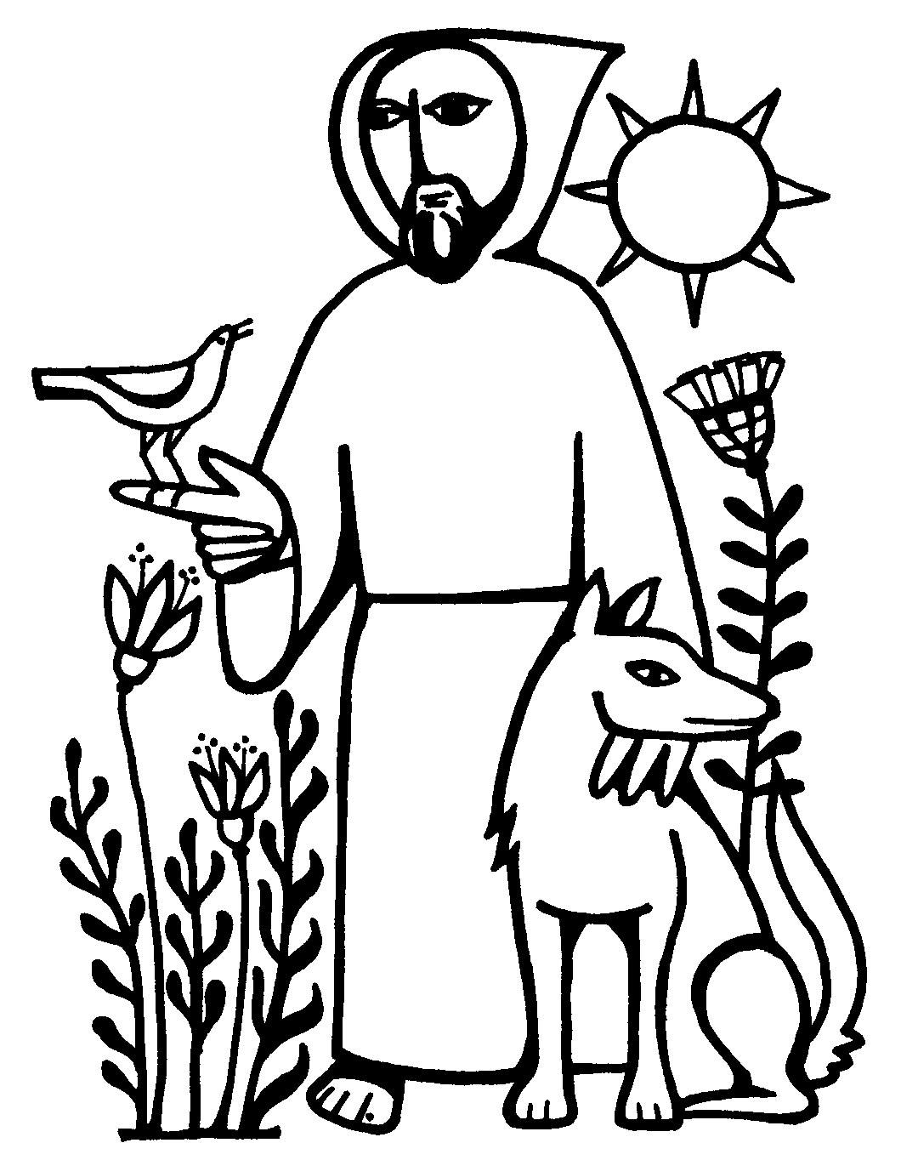
Austin Presbyterian
Theological Seminary

Blessing of the Animals
OPENING

Leader: O Lord, open my lips.
People: and my mouth shall proclaim your praise.

Thanksgiving for Baptism: <pour water with hands at each petition>

L: Ever-living God, author of creation, we give you thanks for your gift of water that brings life and refreshes the earth. For this gift…
P: We praise you, God.
L: You moved over the face of the waters; you divided the water from the dry land. You brought forth living creatures, and you drew us into the covenant of life with all living things. For this gift…
P: We praise you, God.
L: Through the powerful waters of the flood, you washed the whole earth clean and new. You drew us into the covenant of renewal and rebirth with all living things. For this gift…
P: We praise you, God.
L: Liberator God, you brought your people through the waters of freedom and continue to meet us on the borders of justice for all living things. For this gift…
P: We praise you, God.
L: Our sin has turned our face from your gifts of life, rebirth and justice. Humankind has not cherished all our fellow creatures as part of the same covenant. We have hurt the earth and its inhabitants; we have polluted the soil, the air, and the water that brings us life. For these wrongs…
P: We humbly repent.
L: We bless and praise you, for by water and the Word we are cleansed from sin and receive everlasting life. Join us again this day to the saving death of Christ; renew in us the living fountain of your grace and raise us with Christ Jesus to live in newness of life; for you are merciful and you love your whole creation, and with all your creatures we give you glory, through your Son Jesus Christ, in the unity of the Holy Spirit, now and forever.
P: AMEN.
SONG: Let all things now Living
1st READING

Prayer for Illumination:
Living God,
Help us so to hear your holy Word
that we may truly understand;
that, understanding, we may believe,
and , believing,
we may follow in all faithfulness and obedience,
Seeking your honor and glory in all that we do;
Through Christ our Lord. AMEN

Leader: The reading is found in Genesis. Listen for the Word of God:
<Genesis 9:3-17> Then God said to Noah and to his sons with him, ‘As for me, I am establishing my covenant with you and your descendants after you, and with every living creature that is with you, the birds, the domestic animals, and every animal of the earth with you, as many as came out of the ark. I establish my covenant with you, that never again shall all flesh be cut off by the waters of a flood, and never again shall there be a flood to destroy the earth.’ God said, ‘This is the sign of the covenant that I make between me and you and every living creature that is with you, for all future generations: I have set my bow in the clouds, and it shall be a sign of the covenant between me and the earth. When I bring clouds over the earth and the bow is seen in the clouds, I will remember my covenant that is between me and you and every living creature of all flesh; and the waters shall never again become a flood to destroy all flesh. When the bow is in the clouds, I will see it and remember the everlasting covenant between God and every living creature of all flesh that is on the earth.’ God said to Noah, ‘This is the sign of the covenant that I have established between me and all flesh that is on the earth.’
L: The Word of the Lord
P: Thanks be to God.
PSALM 104
L: Let us respond together to Psalm 104.

P: Bless the Lord, O my soul;
L: O Lord my God, how excellent is your greatness!
you are clothed with majesty and splendor.
You send the springs into the valleys;
they flow between the mountains.
Bless the Lord, O my soul;
All the beasts of the field drink their fill from them,
and the wild asses quench their thirst.
Beside them the birds of the air make their nests
and sing among the branches.
Bless the Lord, O my soul;
You water the mountains from your dwelling on high;
the earth is fully satisfied by the fruit of your works.
Bless the Lord, O my soul;
You make grass grow for flocks and herds
and plants to serve mankind;
That they may bring forth food from the earth,
and wine to gladden our hearts,
Bless the Lord, O my soul;
O Lord, how manifold are your works!
in wisdom you have made them all;
the earth is full of your creatures.
Bless the Lord, O my soul.

2ND READING

Leader: The reading is found in the Gospel of Matthew. Listen for the Word of God.

<Matthew 6:25-34>"Therefore I tell you, do not worry about your life, what you will eat or what you will drink, or about your body, what you will wear. Is not life more than food, and the body more than clothing? Look at the birds of the air; they neither sow nor reap nor gather into barns, and yet your heavenly Father feeds them. Are you not of more value than they? And can any of you by worrying add a single hour to your span of life? And why do you worry about clothing? Consider the lilies of the field, how they grow; they neither toil nor spin, yet I tell you, even Solomon in all his glory was not clothed like one of these. But if God so clothes the grass of the field, which is alive today and tomorrow is thrown into the oven, will he not much more clothe you — you of little faith? Therefore do not worry, saying, 'What will we eat?' or 'What will we drink?' or 'What will we wear?' For it is the Gentiles who strive for all these things; and indeed your heavenly Father knows that you need all these things. But strive first for the kingdom of God and his righteousness, and all these things will be given to you as well.
"So do not worry about tomorrow, for tomorrow will bring worries of its own. Today's trouble is enough for today."

L: The Word of the Lord
P: Thanks be to God.
SONG: All Creatures, Worship God Most High!

BLESSINGS & PRAYERS

L: The Lord be with you.
P: And also with you.

L: Let us pray.
Mighty God of mercy, we thank you for the resurrection dawn, bringing the glory of our risen Lord who makes every day new.
Especially we thank you—
- For the sustaining goodness of your creation; for light, for water, for land and all your creatures that enliven our world. O God, for this…
P: We give you thanks.
- For the new creation in Christ and all gifts of healing and forgiveness. Turn our actions toward your heart, so that we are a reflection of your love and mercy. O God, for this…
P: We give you thanks.
- For the gifts of relationship with others: family, friends and ones we've yet to meet. Today, we rejoice in the special companionship of pets and service animals. Our love for them gives us a glimpse of your boundless love for all of creation. O God, for this…
P: We give you thanks.
- We remember our loved ones who have died, both people and pets. Comfort us in our sorrow and grief. Help us to see those in the world who die without feeling loved, both people and animals. Stir in us your mercy and compassion. O God, for this…
P: We give you thanks.
- For the communion of faith in your church, and those that have come before us on the path of faith, especially your servant, Francis. O God, for this…
P: We give you thanks.
- Renew our faith, increase our hope, and deepen our love, for the sake of a world in need. Faithful to you Word, O God, draw ear to all who call on you; through Jesus Christ, our Savior and Lord, to whom, with you and the Holy Spirit, be honor and glory forever. P: AMEN.

L: I invite you to move to the cross, font or pulpit with your pets so that they may be blessed. Solo/Taize sung during the Blessing of the Animals.
Blessings:
Bless O God, this your creature, and all who are involved in its care and protection.
OR for service animals:
Bless O God, this your creature, and all who rely on it for service and companionship.

L: Let us pray together:
P: Lord, may we love all your creation,
all the earth and every grain of sand in it.
May we love every leaf, every ray of your light.

May we love the animals;
you have given them the rudiments of thought and joy untroubled.
Let us not trouble it;
Let us not harass them,
Let us not deprive them of their happiness,
Let us not work against your intent.

For we acknowledge unto you that all is like an ocean,
All is flowing and blending,
And that to withhold any measure of love from anything in your universe
Is to withhold that same measure from you.
AMEN. <Prayer attributed to Fyodor Mikhailovich Dostoevsky (1821-1881)>

L: May the LORD bless us and keep us,
May the LORD's face shine upon us and be gracious to us.
May the LORD look upon us with favor
And give us peace. +
P: AMEN.

L: Go in peace, to love and serve all of creation.
P: Thanks be to God.

