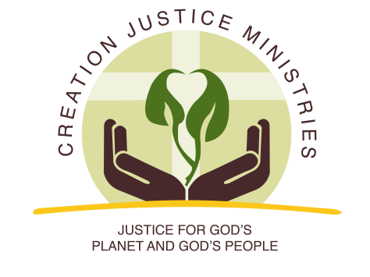
NEWS RELEASE

For Immediate Release:
September 15, 2016
Contact: Shantha Ready Alonso, 760.408.0688 (mobile) shantha@creationjustice.org
Christian Communities Celebrate Designation of
Northeast Canyons and Seamounts Marine National Monument
Monuments Protect God’s Creation for Generations to Come

Washington, DC – Today, President Obama made history by designating the first marine national monument in the Atlantic Ocean. The monument area includes canyons deeper than the Grand Canyon, and seamounts nearly as tall as the Rocky Mountains. This unique underwater environment is a haven for hundreds of species which inhabit the area from the ocean floor to the surface, including deep sea corals, rare fish, a variety of marine mammals, and seabirds.

Christian communities strongly backed the national monument proposal throughout 2016, having offered a public prayer service, delivered various sign-on letters, published opinion pieces, and participated in decision-maker meetings. Religious community members who participated in advocating for the monument designation are thrilled.

Chair of the Rhode Island State Council of Churches board of directors Barbara Scott said of the designation, “we are forever grateful that President Obama has heard our pleas and will be designating this area as the first undersea national monument in the Atlantic. Hallelujah!”

Executive Director of Creation Justice Ministries Shantha Ready Alonso recognized the value of the monument for climate resilience and species protection: “By providing permanent protection to Coral Canyons and Seamounts, President Obama has proven himself to be a great steward of God’s creation, which is facing increased threats from climate change. Safeguarding sacred places like this is important for all living beings to fulfill their Genesis calling to be fruitful and multiply, ensuring a future of abundance for all of us.”

Creation Justice Ministries represents the creation care policies of 38 Christian communions, including Baptist conventions, mainline Protestants, Historically Black Churches, Peace Churches, and Orthodox communions. Learn more about Creation Justice Ministries’ advocacy for the Atlantic marine monument at www.creationjustice.org/ocean-treasures

CHRISTIAN LEADERS CELEBRATE THE
NORTHEAST CANYONS AND SEAMOUNTS MARINE NATIONAL MONUMENT

Future generations will look back on this moment with deep gratitude for the vision and witness that this official designation brings to one of the most critical and vibrant natural resources in New England waterways. This historic designation offers the possibility of a thriving future for God’s sacred creation.

The Reverend Stephanie M. Johnson
Convener, New England Regional Environmental Ministries Network
Co-Chair, Episcopal Church’s Advisory Council on Care of Creation

“It is such a privilege to have been a part of the effort to help to protect and defend for all time New England's Coral Canyons and Seamounts: a sacred, God-given creation, that cannot advocate for itself without the constancy of a group like Creation Justice Ministries. Along with Save the Bay Rhode Island, the Rhode Island State Council of Churches joined this campaign of advocacy for a most wonderful part of our natural world many months ago. We are forever grateful that President Obama has heard our pleas and will be designating this area as the first undersea national monument in the Atlantic. Hallelujah!”
Barbara Scott, Chair, Board of Governors, Rhode Island State Council of Churches

“The rare and amazing marine creation in our new national monument in the Atlantic merits our wonder and awe. God’s creation deserves this recognition and care, and we are grateful!”
Rev. Laura Everett, Executive Director, Massachusetts Council of Churches

“Designating this monument is another sign that human beings are beginning to take seriously our urgent call to protect God’s creation. In the words of Habbakuk, the day is drawing near when the earth shall be filled with the glory of God as the waters cover the sea. Thank you, President Obama.”
Rev. Margaret Bullitt-Jonas, Missioner for Creation Care
Episcopal Diocese of Massachusetts and United Church of Christ Massachusetts Conference

“Thank you, President Obama, for establishing this monument, which will help us as New Englanders to become more mindful of our role as caretakers of God’s marine creation.”
The Reverend Tom Carr
Pastor, Second Baptist Church of Suffield
Chair, Inter-religious Eco-Justice Network of Connecticut
Co-Chair, American Baptist Creation Justice Network

“By providing permanent protection to Coral Canyons and Seamounts, President Obama has proven himself to be a great steward of God’s creation, which is facing increased threats from climate change. Safeguarding sacred places like this is important for all living beings to fulfill their Genesis calling to be fruitful and multiply, ensuring a future of abundance for all of us.”
Shantha Ready Alonso, Executive Director, Creation Justice Ministries

