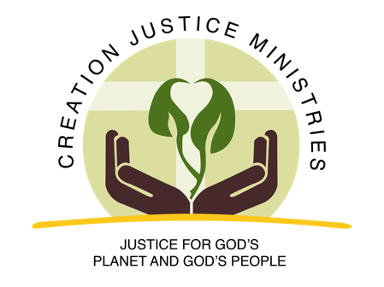
50 Years of Earth Days and Beyond
1970 The first Earth Day is established on the birthday of Saint Francis of Assisi (April 22nd). Environmental Protection Agency also established.

1972 The Clean Water Act is passed by the U.S. Congress, placing a limit on the flow of raw sewage into rivers, lakes, and streams.

1973 The Endangered Species Act is passed to protect wildlife.

1982 Warren County (North Carolina) Civil Disobedience Campaign launches the modern environmental justice movement. Over 6 weeks, more than 500 people were arrested in protest against the dumping of toxic waste in predominantly black community.

1987 Toxic Waste and Race in the United States report is published by the United Church of Christ Commission for Racial Justice and for the first time documents the pervasiveness of environmental racism in the U.S.; Dr. Ben Chavis of the United Church of Christ coins the term “environmental racism.”
1989 The late Ecumenical Patriarch Dimitrios I of the Orthodox Church establishes September 1st as a day of prayer for the environment.
1991 The First National People of Color Environmental Leadership Summit gathers more than 600 people in Washington, DC and adopts seventeen Principles of Environmental Justice.
1996 Southwest Network for Economic and Environmental Justice meets in Jemez, New Mexico and releases the Jemez Principles for Democratic Organizing, which continue to be widely used in the environmental justice movement
1997 Thirty-eight nations, including the United States, sign the Kyoto Protocol, agreeing to reduce their greenhouse gas emissions by about 5% over 15 years.
2005 Hurricane Katrina, a Category 5 hurricane, decimates the Gulf coast, especially the area around New Orleans. Over 1,800 died as a result of the storm and the ensuing flooding.
2006 Presbyterian Church (USA) passes a Carbon Neutral Resolution strongly urging all Presbyterians to “immediately aspire to live carbon neutral lives.” It was the first resolution by a major religious body to call upon its followers to become carbon neutral.
2007 The Third European Ecumenical Assembly calls for a five week liturgical celebration called a "Time for Creation." Now known as the Season of Creation, it begins on September 1st and ends on the commemoration of Saint Francis of Assisi on October 4th.
2008 The World Council of Churches calls on churches to celebrate five weeks of “Time for Creation” each year between September 1-October 4, setting the precedent for what later became known as the “Season of Creation.” The National Council of Churches releases The Green Bible, published by Harper Bibles, to highlight the creation-centered ethos of the Bible.
2013 The United Church of Christ’s General Synod becomes the first major religious body to call for divestment from fossil fuels.
2014 The Flint (Michigan) Water Crisis begins, affecting thousands of people, many of them children. Several deaths are attributed to the crisis, although the effects of the lead poisoning from the water will last for decades.

2015 Pope Francis issues his encyclical Laudato Si': On Care for Our Common Home Pope Francis calls on Roman Catholics to honor September 1st as the World Day of Prayer for the Care of Creation, building on the tradition led by Ecumenical Patriarch Bartholomew.
2016 The United States officially becomes a signatory of the Paris Climate Agreement, an international effort to reduce global greenhouse gas emissions and to offer assistance developing nations in their climate mitigation and adaptation efforts.
2016 Protesters join in solidarity with the Standing Rock Sioux Tribe in their efforts to stop the construction of a pipeline across their lands.
2017 The Christian Church (Disciples of Christ) sets a new bar of ambition by calling on individuals, congregations, and ministries to achieve carbon neutrality by 2030 and pull carbon out of the atmosphere by 2035.
2018 The UN’s Intergovernmental Panel on Climate Change (IPCC) issues a call for immediate action on the climate crisis.
2019 The Global Climate Strike, demanding governments take action on climate change, draws over seven million participants from 185 countries.

2020 50th Anniversary of the first Earth Day.

2030 IPCC deadline to meet the 1.5°C of global warming by cutting emissions.

http://w2.vatican.va/content/francesco/en/encyclicals/documents/papa-francesco_20150524_enciclica-laudato-si.html
IPCC, 2018: Summary for Policymakers. In: Global Warming of 1.5°C. World Meteorological Organization, Geneva, Switzerland, 32 pp.

